CURSOR CONTROL USING EYE MOVEMENT

A PROJECT REPORT

Submitted by

SATVIK SAMB SAXENA

Under the guidance of

Miss. Monica Catherine

(Assistant Professor, Department of Information Technology)

in partial fulfillment for the award of the degree

of

BACHELOR OF TECHNOLOGY

in

INFORMATION TECHNOLOGY

of

FACULTY OF ENGINEERING AND TECHNOLOGY


S.R.M. Nagar, Kattankulathur, Kancheepuram District

OCTOBER 2018

SRM UNIVERSITY

(Under Section 3 of UGC Act, 1956)

BONAFIDE CERTIFICATE

Certified that this project report titled “CURSOR CONTROL USING EYE MOVEMENT” is the bonafide work of “ SATVIK SAMB SAXENA”, who carried out the project work under my supervision. Certified further, that to the best of my knowledge the work reported herein does not form any other project report or dissertation on the basis of which a degree or award was conferred on an earlier occasion on this or any other candidate.

SIGNATURE _{SIGNATURE}

Miss. Monica Catherine | Dr. G. Vaidvu
GUIDE | HEAD OF THE DEPARTMENT
Assistant Professor | Dept. of Information Technology
Dept. of Information Technology

Signature of the Internal Examiner Signature of the External Examiner

ABSTRACT

The aim of this project is to present a system for controlling the cursor position in a computer by human eye movements. Many modules have been developed to help the physical world interact with the digital world. Here we present a novel approach for Human Computer Interaction (HCI) where, we control cursor movement using a real time camera and color pointers. Our method is to use a camera and computer vision technology, such as image segmentation, background subtraction and color tracking, to control mouse tasks and we show how it can perform everything as current mouse devices can. A color pointer has been used for the object recognition and tracking, so as to implement the module without any physical contact with the system. The application has been created on python environment with operating system as windows 10. This method mainly focuses on the use of a web camera to develop a virtual human computer interaction device in a cost effective manner presents hands free interface between computer and human especially for physically disabled persons.

ACKNOWLEDGEMENTS

I would like to express my deepest gratitude to our guide, Miss. Monica Catherine her valuable guidance, consistent encouragement, personal caring, timely help and providing me with an excellent atmosphere for doing research. All through the work, in spite of his busy schedule, she has extended cheerful and cordial support to me for completing this research work.

Satvik Saxena

iv

TABLE OF CONTENTS

ABSTRACT |  |  | iii
ACKNOWLEDGEMENTS |  |  | iv
LIST OF FIGURES |  |  | vii
ABBREVIATIONS |  |  | viii
LIST OF SYMBOLS |  |  | ix
1 | Introduction |  | 1
 | 1.1 | Cursor Control using Eye Movement . . . . . . . . . . . . . . . . | 1
2 | 1.2 Literature Survey . . . . . . . . . . . . . . . . . . . . . . . . . . . . . . . . . . .  Literature Survey |  | 2  3
 | 2.1 | Robust Real-time Object Detection . . . . . . . . . . . . . . . . . . | 3
 | 2.2 | Image Processing
 |  | . . . . . . . . . . . . . . . . . . . . . . . . . . . . . . . | 4
 | 2.3 | Image Analysis . . . . . . . | 5
 | 2.4 | Speeded-up Robust Features (SURF) . . . . . . . . . . . . . . . . . | 6
 | 2.5 | Distinctive Image Features from Scale-Invariant Key position . . . . | 7
3 | Goals of the System |  | 8
4 | System Design |  | 9
 | 4.1 | Proposed System . . . . . . . . . . . . . . . . . . . . . . . . . . . | 9
 | 4.2 | Architecture . . . . . . . . . . . . . . . . . . . . . . . . . . . . . . | 9
 | 4.3 | Requirements . . . . . . . . . . . . . . . . . . . . . . . . . . . . . | 11
5 | UML Diagrams |  | 13
6 | Design and Implementation |  | 15

v

 | 6.1 | Detecting face and eyes. . . . . . . . . . . . . . . . . . . . . . . . | 16
 |  | 6.1.1 Face Detection . . . . . . . . . . . . . . . . . . . . . . . . | 16
 |  | 6.1.2 Eye Detection . . . . . . . . . . . . . . . . . . . . . . . . . | 17
 | 6.2 | Locating pupil center . . . . . . . . . . . . . . . . . . . . . . . . . | 18
 | 6.3 | Finding the reference point . . . . . . . . . . . . . . . . . . . . . . | 19
 | 6.4 | Moving the cursor and detecting the blinks . . . . . . . . . . . . . . | 22
 | 6.5 | Training the transformation from eye to screen coordinates . . . . . | 22
7 | Measurement of Results |  | 24
8 | Applications |  | 25
9 | Conclusion |  | 26
10 | Future Enhancement |  | 28

LIST OF FIGURES

4.1 | Architecture . . . . . . . . . . . . . . . . . . . . . . . . . . . . . . | 10
5.1 | Use Case diagram . . . . . . . . . . . . . . . . . . . . . . . . . . . | 13
5.2 | Sequence diagram . . . . . . . . . . . . . . . . . . . . . . . . . . . | 14
6.1 | Process flow . . . . . . . . . . . . . . . . . . . . . . . . . . . . . . | 15
6.2 | Using OpenCV to find the eyes and face . . . . . . . . . . . . . . . | 17
6.3 | Pupil center . . . . . . . . . . . . . . . . . . . . . . . . . . . . . . | 18
6.4 | Equation for pupil center . . . . . . . . . . . . . . . . . . . . . . . | 18
6.5 | Eye probabilities overlaid . . . . . . . . . . . . . . . . . . . . . . . | 20
6.6 | Plotting reference point . . . . . . . . . . . . . . . . . . . . . . . . | 21

vii

ABBREVIATIONS AND KEYWORDS

HCI : Human Computer Interaction

OpenCV : Open Source Computer Vision Library

Eye ball movement

Python

Web camera

Computer

viii

List of symbols

[c ] | Pupil center
fg(i)g | Gradient vector
fd_{i}^{T} g | Gradient vector

ix

CHAPTER 1

INTRODUCTION

1.1 Cursor Control using Eye Movement

As the computer technology is grow up, the importance of human computer interaction is rapidly increasing. Most of the mobile devices and laptops are using touch screen technology. But this technology is still not cheap enough to be used on desktop systems. Creating a virtual human computer interactive module such as mouse or keyboard, can be an alternative way for the touch screen. The motivation is to create an object tracking application to interact with the computer, and develop a virtual human computer interaction device. Implementing the detection of gaze direction has several applications and also scope in the future. This feature could be implemented in different banks to detect frauds, ticket booking systems.
In our work, we used Python to call web camera which is set to take images continuously from the eye focusing pupil. With the help of different image processing techniques, the eye recognition and tracking is achieved. The processing techniques involve an image subtraction algorithm to detect colors. The color is detected from the image pixel and the pixel position is mapped into mouse input position, the root class java program for mouse movement is called to move the cursor [1].
In e-commerce websites it can be used to detect where the customer is looking and analyze what catches their attention. Eye tracking allows us to know if users are looking at the screen or reading information. It also helps in determining the attention of the user on the screen. Analyzing such information can help software engineers improve their user interface.

The greatest challenge is develop an economically feasible application, which is also hardware independent. This is to ensure a person can easily make use of this application without having much difficulty in setting up the physical computer setup. Basically the main objective is to develop an application that can help a person to interact with the computer, and a virtual human computer interaction system, where no physical contact with the device is required and also to provide an easier HCI routine.

EyeCursor is a real-time eye tracking application which tracks the eye movement and helps in accomplishing various operations which can be performed using a phys-ical mouse. The algorithm begins by using the Open Source Computer Vision Li-brary (OpenCV) library’s application of the Haar cascade detector to locate the face and the two eyes in a frame of the image captured. We use simple facial geometry to remove incorrect eye and face detections, and thus produce very dependable rectangular boxes around the user’s eyes.

The unique selling point of this application lies in the fact that it uses machine learning to learn and improve the movement of the cursor every time with a new user and new sort of eye movement. This feature can also be personalized according to different type of users. Different users have different facial features, and the application is trained to work accordingly.

1.2 System approach
• Capturing real time video using Web-Camera focusing pupil of eye.
• Processing the individual image frame.
• Flipping of each image frame.
• Conversion of each frame to a grey scale image.
• Color detection and extraction of the different colors (RGB) from flipped gray scale image.
• Conversion of the detected image into a binary image.
• Finding the region of the image and calculating its centroid.
• Mouse Movement (Figure ).

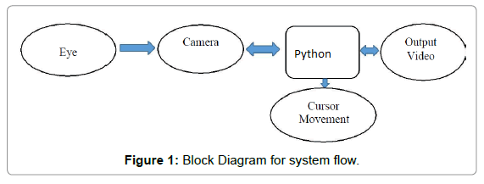

1.3 Acquisition
As a primary section, Acquisition is very important. Obtaining a clear image of the pupil in the eye is crucial to the eye-tracking process. A modified low cost USB webcam is used for capturing a close-up picture of one eye pupil. An integral part of the design process, therefore, is to determine the optimum camera settings and light source positions to produce a clear image. Pyhton program is used to call the webcam for acquiring the real time video input data.

2
CHAPTER 2

LITERATURE SURVEY

2.1 Robust Real-time Object Detection

Jones (Jones) suggested for the use of new algorithms which can be used to create an application for fast detection of object movements. At the end this resulted in a face detection system which was best at its time results. The face recognition system was much better than the previous attempts as it could detect faces faster. Performance of this system was much better than the previous systems. The working capacity of this system was 374 by 278 component pictures and faces at the rate of fifteen frames per second on an average 700 MHz Intel Pentium 3 which was excellent and exceptional according to the experts. These face detection systems use secondary information, like colored pictures or image variations in videos.

These were used to achieve high frame rates function completely on the knowledge of a single image which is monochromatic. These various sources of data could be combined with their system to improve performance by a great factor i.e. achieve even higher frame rates than the present existing technologies.

2.2 Image Processing

Image processing is any form of signal processing for which the input is an image, such as photographs or frames of video; the output of image processing can be either an image or a set of characteristics or parameters related to the image. Most image-processing techniques involve treating the image as a two-dimensional signal and applying standard signal processing techniques to it. Image processing usually refers to digital image processing, but optical and analog image processing are also possible. Here image processing is in the sense that we are splitting each pixel of the image into RGB components. This is done by traversing through the image, retrieving each pixel, extracting RGB values and then comparing the color values to the RGB values.

4

2.3 Image analysis

Image analysis is the extraction of meaningful information from images; mainly from digital images by means of digital image processing techniques. Image analysis tasks can be as simple as reading bar coded tags or as sophisticated as identifying a person from their face. In this project we do various image analyzing techniques. The main thing done is the color detection. At first we receive an image from the web cam. Then each pixel is retrieved from the image and extracts the red, green and blue values (RGB) from each pixel. Now we can easily detect a particular color since all the colors are combinations of RGB values. Digital image processing is the use of computer algorithms to perform image processing on digital images. As a subcategory or field of digital signal processing, digital image processing has many advantages over analog image processing. It allows a much wider range of algorithms to be applied to the input data and can avoid problems such as the buildup of noise and signal distortion during processing. Since images are defined over two dimensions digital image processing may be modeled in the form of multidimensional system [3-5].

2.3.1 Flipping of images

When the camera captures an image, it is inverted. This means that if we move the color pointer towards the left, the image of the pointer moves towards the right and vice-versa. It’s similar to an image obtained when we stand in front of a mirror (Left is detected as right and right is detected as left). To avoid this problem we need to vertically flip the image. The image captured is an RGB image and flipping actions cannot be directly performed on it. So the individual color channels of the image are separated and then they are flipped individually. After flipping the red, blue and green colored channels individually, they are concatenated and a flipped RGB image is obtained.
5

2.4 Speeded-up Robust Features (SURF)

Bay (2008) in 2008 expressed that the errand of discovering point correspondences between two pictures of a similar scene or question is a piece of numerous PC vision applications. Picture enlistment, camera alignment, question acknowledgment, and pic-ture recovery are only a couple. The scan for discrete picture point correspondences can be partitioned into three primary advances. To begin with, ’intrigue focuses’ are cho-sen at particular areas in the picture, for example, corners, blobs, and T-intersections. The most profitable property of an intrigue point identifier is its repeatability. The re-peatability communicates the unwavering quality of an identifier for finding the same physical intrigue focuses under various review conditions. Next, the area of each in-trigue point is spoken to by a component vector. This descriptor must be particular and in the meantime strong to the commotion, discovery relocations and geometric what’s more, photometric disfigurements. At last, the descriptor vectors are coordinated be-tween distinctive pictures.

The coordinating depends on a separation between the vectors, e.g. the Mahalanobis or on the other hand Euclidean separation. The measurement of the descriptor has an immediate effect on the time this takes, and fewer measurements are alluring for quick intrigue point coordinating. In any case, bring down dimensional element vectors are when all is said in done less unmistakable than their high-dimensional partners. It has been our objective to create both a locator, what’s more, a descriptor that, in contrast with the cutting edge, are quick to process while not giving up execution. So as to succeed, one needs to strike a harmony between the above prerequisites like rearranging the identification conspire while keeping it exact, also, lessening the descriptor’s size while keeping it adequately unmistakable.

6

2.5 Steps Involved in Image Processing

Step 1: Capture the video frames using the video input function.

Step 2: Set the properties of video object.

Step 3: Start the video acquisition.

Step 4: Set a loop that starts after 2000 frames of acquisition. This loop contains the following steps:

• Get the snapshot of the current frame.

• Convert the RGB image into grayscale image.

• Now to track the black objects in real time we have to complement the greyscale.

• Convert the resulting complemented grey scale image into a binary image.

• Remove all those pixels which are less than pixels.

• Label all the connected components in the image to perform image analysis, here we get a set of properties for each labelled region.

• Display the image.

• Again a loop is used to bind the black objects in a rectangular box.

Step 5: Stop the video acquisition.

Step 6: Flush all the image data stored in the memory buffer.

Step 7: Clear all the variables.

Step 8: End.

2.5.1 Processing

After the acquisition we have to set a loop that stops after certain frames and the snapshot of current frame is acquired. In Processing, first we convert the color image into grey, because it is easy to process the grey image in single color instead of three colors. Grey images requires less time in processing. Then we apply median filter to remove noise from images or frames obtained from the video. The image or frame filtered out with the help of the command ‘medfilt2’ present in the Image Processing Toolbox.

2.5.2 Feature extraction

Selecting the right feature plays a critical role in tracking. We are focused to track the black color in the real time video in order to track the motion of pupil.

7

CHAPTER 3

GOALS OF THE SYSTEM

Some of the goals of this system are:

- Capability to control the mouse without the use of the hand.

- A system that ensures Vision based machine

- Capability of controlling mouse functions using eye and head movement of the user.

- To eliminate the limitations of stationary head

- To provide real time eye tracking
CHAPTER 4

SYSTEM DESIGN

4.1 Proposed System

There are few eye gaze tracking applications in the market for certain specific needs, which require luxurious infrared cameras. Most of them are either not fully functional or are not used in India, actively. Through our eye gaze detector, users of the user interface can interact with applications and software. They can interact with the system with just the movement of their eyes. The paper proposes an application which can be used enthusiastically when using a desktop, laptop and other such electronic devices. The primary objectives of the application are:

- Develop an application for tracking the eye gaze and learning the data about different users

- After training the system, the application can now determine our eye gaze and track where our eye gaze is at the moment

- On detecting the blink of the user, the cursor clicks and interacts with icons and applications on the screen of the electronic device

4.2 Architecture

The architecture of this system primarily consists of a webcam enabled computer, web-cam can take videos. The OpenCV haarcascade library allows us to detect the eyes and face with ease. Then user’s side of the script shows the user’s live video on his or her screen and tries to get the reference point first by finding the pupil center and then by finding the joint pupil probability. The user’s movement is read with the help of refer-ence point we try to calculate the gaze position which is then used for moving the cursor to that position. We also use pythonautogui library to click the cursor on the blink, but the blink should be for five seconds so that we can differentiate between a natural blink

and the blink meant for a click. The below diagram describes the architecture of our

system:
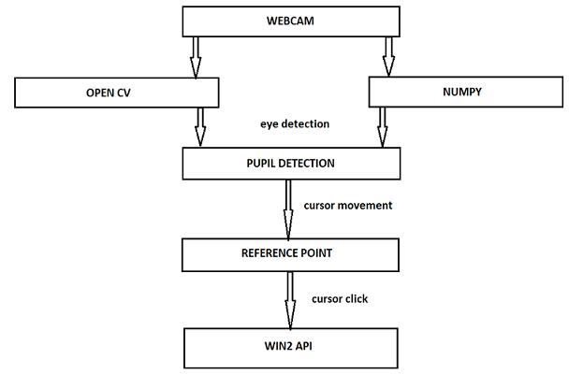

Figure 4.1: Architecture

10

4.3 Requirements

For building the eye gaze tracking application, a laptop web camera is used. It is de-veloped using JetBrains PyCharm Community Edition 2017.2.4 x64 IDE. To detect the eyes and facial features some of pythons library were used. We used haar cascade and OpenCV library. OpenCV is an open source computer vision and machine learning software library Haar Cascade library is used to identify the facial features of a face. Numpy library was also required for the project. It’s a Python library that provides a multidimensional array object, various derived objects (such as masked arrays and matrices), and an assortment of routines for fast operations on arrays, including mathematical, logical, shape manipulation, sorting, selecting, I/O and more. To detect the click. For this, we used python’s win2api which is used as pyautogui to control mouse movements like a click.

OpenCV (Open Source Computer Vision Library) is released under a BSD permit and subsequently it’s free for both scholarly and business utilize. It has C++, Python and Java interfaces and backings Windows, Linux, Mac OS, iOS and Android. OpenCV was intended for computational proficiency and with a solid spotlight on constant appli-cations. Written in streamlined C/C++, the library can exploit multi-center preparing. Empowered with OpenCL, it can exploit the equipment speeding up of the basic het-erogeneous figure stage.

Object Detection utilizing Haar feature based course classifiers is a powerful ques-tion identification technique proposed by Paul Viola and Michael Jones in their paper, "Fast Object Detection utilizing a Boosted Cascade of Simple Features" in 2001. It is a machine learning based approach where a course work is prepared from a considerable measure of positive and negative pictures. It is then used to identify protests in different pictures. Here we will work with object recognition. At first, the calculation needs a considerable measure of positive (pictures of countenances) and negative (pictures without faces) to prepare the classifier. At that point we have to remove highlights from it. For this, haar highlights appeared in underneath picture are utilized. They are much the same as our convolutional portion. Each component is a solitary esteem acquired by subtracting entirety of pixels under white rectangle from total of pixels under dark

11

rectangle. Presently all conceivable sizes and areas of every piece is utilized to figure a lot of highlights. (Simply envision what amount of calculation it needs? Indeed, even a 24x24 window comes about more than 160000 highlights). For each element estimation, we have to discover total of pixels under white and dark rectangles. To settle this, they presented the vital pictures. It streamlines count of total of pixels, how substantial might be the quantity of pixels, to a task including only four pixels. It makes things super-quick.

12

CHAPTER 5

UML DIAGRAMS
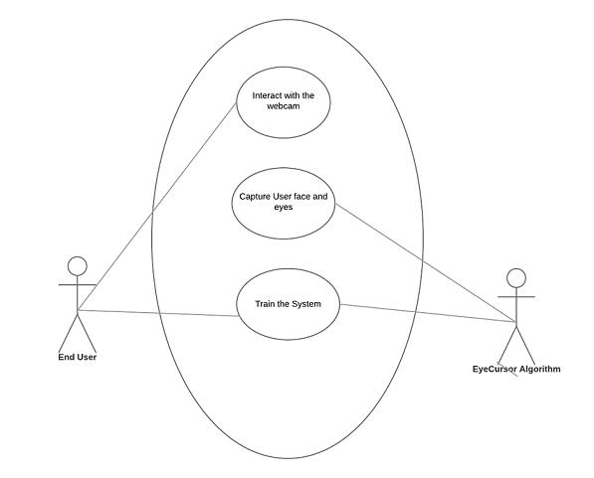

Figure 5.1: Use Case diagram
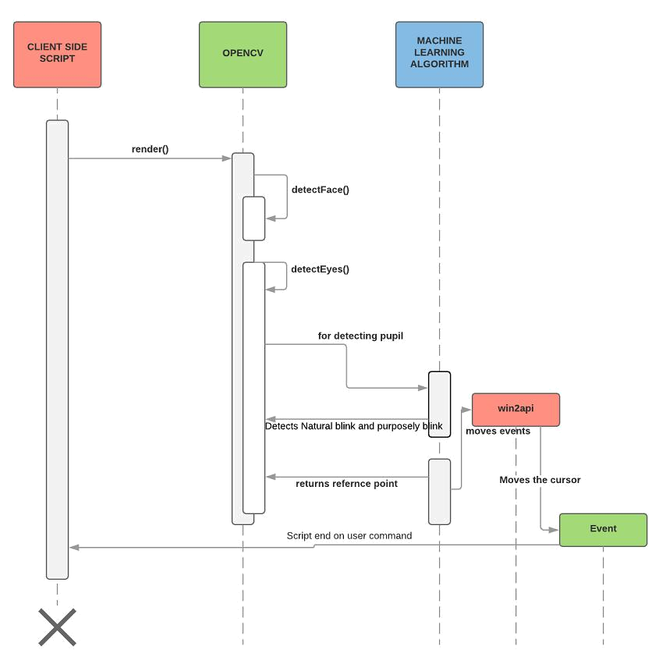

Figure 5.2: Sequence diagram

14

CHAPTER 6

DESIGN AND IMPLEMENTATION

In this chapter, the program coding related to your work using python can be presented here.
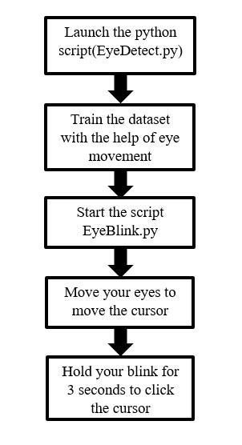

Figure 6.1: Process flow

The general workflow of the system can be seen in fig above. On launching the script, EyeDetect.py starts detecting the user’s eyes and face. It tries to train itself and stores the face of user and his/her eye movements, this way it tries to estimate gaze direction.

The EyeCursor can be divided into the following four modules:

- Locating eyes using python’s OpenCV.

- Finding the centre of eyes i.e. pupil (darkest part in our eye).

- Finding the reference point of eyes using joint pupil probability.

- Using eye blinks and movements to operate click and movement of the cursor.

6.1 Detecting face and eyes.

This paper intends to present an eye gaze tracking algorithm which will be used for moving the cursor and performing various functions i.e. face and eyes extraction is an important task in this regard.

6.1.1 Face Detection

Face detection is a classification problem because it requires classification acquired image into face and non-face areas. A fast and tough algorithm for object detection is utilised to perform the extraction of face and eyes features. It trails an approach based upon machine learning. Haar features based classifiers can be trained for detection of several objects which includes face, eyes. These classifiers are made especially for false positive and false negative samples as well. A set consisting of very simple features are gathered from the data used for training in the application. Haar features are calculated by calculating the difference between regions which are dark and regions which have light pixel value. A edge value is fixed at stage fixed for learning i.e. feature is said to be present if difference value comes out to be greater than the value fixed as threshold. Face and eyes detection is a complex procedure, require much computations to solve this sorting problem. For this purpose, assimilated images are down-sampled, face is perceived and face co-ordinates are mapped to unique image using simple intentions. Identical rehearsal is educated for eye patch abstraction to diminish the totalling time; this tactic has proved to be actual in order to achieve real time treating of the frame.

16

6.1.2 Eye Detection

Eye corners are such an essential eye include, to the point that a ton of data about eyes can be removed utilizing eye corner areas. When eye corner areas are known, they can be utilized to appraise eye width, eye stature and in particular this data can be used to find focal point of eye. Another reality is set up through a few examinations that eye corners extraction isn’t reasonable, to become more acquainted with about mobile territory for iris in eye to follow the ’Test Area’. For this reason, after investigation it was presumed that PC isn’t that insightful to find those limit focuses in eye, client ought to sustain some data at begin and a few strategies must be actualized to utilize this data in smart approach to extricate highlights i.e. portable territory for iris, focus of eye and so forth. To meet this necessity, a basic 4-point adjustment method is outlined. Thought behind outlining such adjustment calculation is, it can be useful to ascertain eye area which will be utilized to examine the ’Test Area’. This straightforward calculation enables the client to take a gander at all corner focuses in free mode. Here ’free mode’ recommends that client is permitted to remain at a corner point for a discretionary time span. This thought encourages the framework to diminish blunders happening because of mistaken pupil recognitions amid calibration.

17

6.2 Locating pupil center

Now we were required to locate the pupil in the eyes. Pupil is the focal and centering portion of eye, situated at focal point of iris. Light goes into eye through pupil, and finding the situation of understudy is foremost purpose of enthusiasm for proposed method. Eye stare projection depends on the relative uprooting of student from focus of eye. Student should be recognized to extend client’s eye stare in the ’Test Area’.
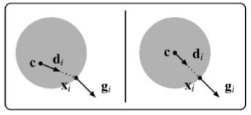

Figure 6.3: Pupil center

If we take a unit vector di which points from the given image location to a gradi-ent location, then the squared dot product with the normalized gradient vector i.e. gi, expressed as
([d_{i}^{T} ]; g^{i})² | (6.1)

This will be as large as possible as if we are at the center of the pupil. We try to do
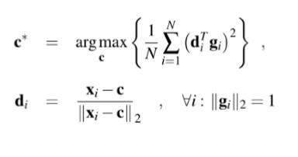

Figure 6.4: Equation for pupil center

this calculation for each image location and each gradient. The c*, pupil center is the location which helps in maximizing the sum of these dot products. For computational

18

efficiency and accuracy, several refinements were necessary: We only do the pupil-center-probability calculation in the dark parts of the image, because the pupil is known to be dark. (To do this, we threshold on pixel brightness, then dilate the image to expand the allowable areas slightly. We must dilate so that our search region includes parts of the pupil where there are bright reflections.) Eyelashes and shadows produce unwanted gradients, which can produce spurious peaks in the pupil-center probability image. Our desired gradients are fairly strong, so we discard all gradients whose magnitude is below the mean. Additionally, we enforce the prior knowledge that the pupil is circular: when calculating pupil-center probability at each pixel, we build a histogram of distance to each gradient location in the image. Only gradients near the most-common distance are included. Thus, only the dominant circle of gradient locations around a candidate point contributes to its pupil-center probability. We also discard gradients which are outside the expected min and max iris radius (based on the size of the eye, as found by the Haar cascade detector). This method finds the center of the iris with fairly high reliability, and acceptable accuracy (usually within 3 pixels). However, it is vulnerable to regions which look similar to a pupil in low-resolution images

6.3 Finding the reference point

Built on research, we enhanced the consistency of our probability by aggregating sev-eral probability estimates. Precisely, we planned a process to trust the estimates from the two eyes: we overlay the chance image from the eye which is on the right side onto the eye which is on the left side and proliferate the two chances. Eye pupils move composed, and therefore seem at the same dwelling in the binary images. But other (noise-producing) parts of the eye are reflected about the center line of the face, and therefore emerge at places which are very different in the two images. The two eye probabilities were aggregated but it was not straightforward. Because the boxes bound-ing our eyes are inaccurate, they cannot be used to align the probability images. We used the understanding that, if head location is firm, the vector after the left eye’s pupil to the right eye’s pupil is almost relentless as the pupils move around. (Especially when the eyes are made to focus on a plane surface, such as a monitor of a computer.) There-fore, if any duplicate region that includes the left eye is loosened by that trajectory, the

19

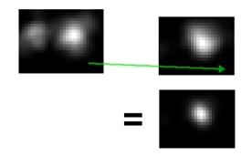

Figure 6.5: Eye probabilities overlaid

left pupil will end up on top of the right pupil. Thus, we can conglomerate the eye prob-ability estimates without needing any absolute mention points on the face. (We distorte both images somewhat before the multiplication, so that a mistake of a few pixels in the pupil-pupil vector still profits a strong peak near the true pupil.) The pupil-to-pupil vector can be obtained from the noisy evaluations of individual pupil positions.

We simply applying a moving-average filter which moves very slowly and steady to discard noise in the estimate of the vector. This method proved very effective. If the pupils are visible to the camera, the joint pupil estimate is within the iris nearly 100 percent of the time. Knowing the coordinates of the pupils is not enough, by itself, to find gaze direction. In order to attribute meaning to the pupil coordinates, we need to express the pupil coordinates in terms of an offset from some location point on the face. The Haar cascade bounding boxes for the face and eyes are not solid enough to serve as reference points, even when be around together. Our preliminary approach was basically to draw a blue dot between the eyes with a dry-erase marker, and apply our single-pupil conclusion code to find the center of the cobalt dot.

The corner (tear duct) of the eye would be good reference point geometrically, be-cause its remoteness from the camera is the same as the pupil, so head revolution would affect it less than other points. Unfortunately, our operation of an eye-corner detector was very untrustworthy. Construction of an eye-corner detector is unimportant, because the corner of the eye looks very dissimilar in need of on whether the test enquiry is look-ing left or right. Its marginal also diverges prominently with light course. We also tried to build an eyebrow detector, but since that was also unstable and error inclined to, we tried to discover a better approach. A perfect reference idea should be as stable as prob-

20

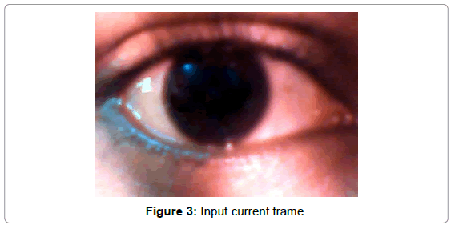
able, but a key insight (which has not yet appeared in any pa per we are aware of) is that the facial reference point does not need to be based on any specific facial feature.

With that in mind we implemented a "virtual reference point" tracking algorithm, based on many image keypoint descriptors. At a high level, our virtual reference point is measured relative to many distinct points on the face, and in each frame, each of these points ’votes’ on where they expect the virtual reference point to be. We weight the votes according to stability and then take a weighted average over the keypoints Ji (Ji). So we found out a reference point as we can see in figure below: A more technical description follows: A more technical description follows: We arbitrarily choose a ’virtual reference point’ on system startup (we chose to use the average of the two eye bound-ing boxes). Then, we locate and uniquely identify image "keypoints" using the popular SURF algorithm Bay (2008). We only use keypoints which are inside the face bounding box and outside the eye bounding boxes, to discard the pupils and the background. For each new keypoints, we record the vector from each keypoint to our virtual reference point (this vector will be immutable for the rest of the session). In each frame after that, if the same keypoint appears again, we compute its "vote" for the position of the virtual reference point by taking the keypoint’s instantaneous position plus its saved immutable vector. The votes for the virtual reference point are combined in a weighted average. Each keypoint’s vote is weighted by the number of consecutive frames that we’ve found that keypoint. (This is a simple way to ensure that the virtual reference is based on stable keypoints.) This method of averaging the keypoint position + immutable vector, rather than directly averaging the keypoint positions, is important because keypoints appear

21

and disappear due to noise and minor head movements. This would cause a direct average of keypoint positions to jump around. Our method produces a very steady vir-tual reference point even while keypoints are appearing and disappearing. Aside: For matching keypoints between frames, we use the standard image-descriptor matching guidelines pioneered by Lowe (2004). At each keypoint (distinctive blobs or corners in the image) a descriptor vector is computed which characterizes the appearance of that image region. The keypoint descriptors from the current frame are compared to all previously-seen descriptors using Euclidean distance. Two SURF descriptors ’a’ and ’b’ are considered to match if a (from set A, the current frame) is closer to b (from set B, the history) than to the next-closest keypoint in B, by some margin. This is also applied the other way around (by requiring bijective matching in this way, we reduce false positives).
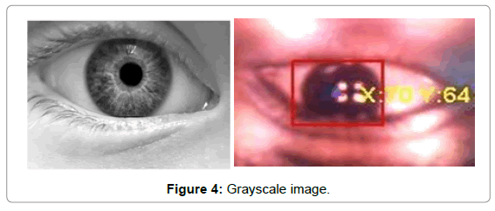

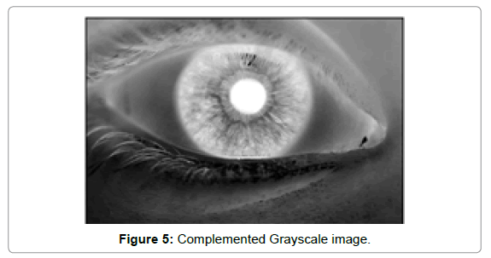

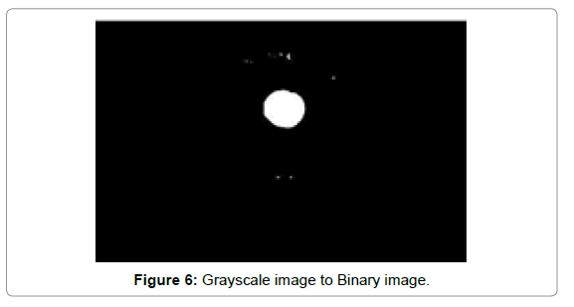

6.4 Moving the cursor and detecting the blinks

Now we are required to use above reference point to move the cursor and also use blink to detect the click. For this, we used python’s win2api which is used as pythonautogui to control mouse movements like a click. This way we achieved our objective.

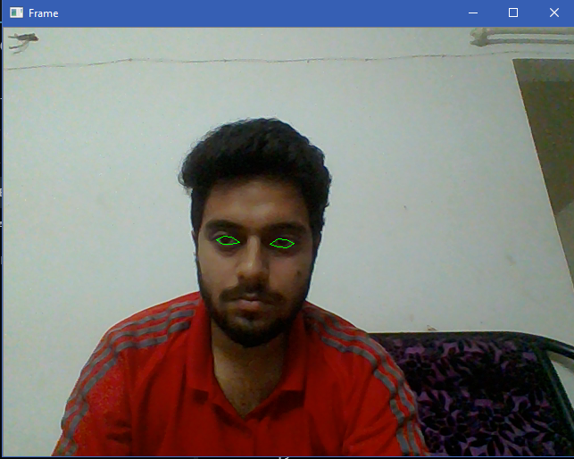
Figure : Using openCV to detect the position of the eyes.

6.5 Training the transformation from eye to screen co-

ordinates

With reference point which is very firm and reliable, we can trust it and find the eye gaze direction in comparison to the reference point. We must next convert gaze direction to a pixel position onscreen. We used the Pygame library to generate a data-extracting application in which the user of the software stares at the mouse cursor and clicks, and the algorithm records the crosshair position and the current location and probabiblity of pupil offset to produce one greatest point for the set used for training. After taking several such data points, we use the Numpy library’s least-squares solver to produce a conversion matrix which relates pupil offset (x,y) to screen position (pixelX, pixelY).

We also input quadratic features, because the relationship between eye offset and screen location is not entirely linear (as the eye looks more to the side, small arrangements of the eye resemble to larger activities on the screen). So our participation feature vector is [x, y, 1, x2, y2, xy]. We use least squares to train a 2 x 6 matrix H such that feature * H = (pixelX, pixelY) unluckily, the least quadrangles fit is strongly degraded if there are outliers in training data (such as when the user’s eyes were closed and the pupil position is incorrect). Accordingly, we use the RANSAC (Random Sample Consensus) algorithm to reject outliers. RANSAC works by choosing an accidental small subsection of the training data, training an H matrix, and by means of only the workout data that is well-described by H to refine H. Many such H contenders are computed (800 in our case), and the best-performing one is chosen. We retrain the system after each click by the user. After roughly 10 to 20 clicks, our algorithm can guess gaze along the topmost of the screen very well. When observing at the very bottom of the display, a user’s pupils are usually not noticeable to a webcam, so the algorithm fails. We therefore overlook the very bottom most area of the screen in the testing below

23

CHAPTER 7

MEASUREMENT OF RESULTS

In adequate lighting conditions, the system performs quite well. In a test of the system with 43 clicks using a webcam with resolution 640 x 480, the median error between predicted and actual click position was 69 pixels, and the mean was 79 pixels. Most of the error was in the vertical direction as evident from Figure 7. This is because the system still has trouble locating the exact center of the pupil vertically. The horizontal median error was only 28 pixels. With our test setup, the overall mean error of 79 pixels corresponds to 2.8 degrees of angular error in estimating gaze direction. Commercial services which use webcams claim accuracies of 2 to 5 degrees. So, our system seems to be comparable in quality to commercial eye-tracking systems. After training, our system can predict gaze location quite well in real time
CHAPTER 8

APPLICATIONS

There are various areas where EyeCursor can be used to replace traditional devices,

some of them are:

- Without hands PC control can be utilized to track faces both accurately and pow-erfully. This helps the advancement of moderate vision based UIs that can be utilized in International Journal of Scientific and Research Publications, Volume 6, Issue 3, March 2016 331 ISSN 2250-3153 www.ijsrp.org a wide range of in-structive or on the other hand recreational applications or even in controlling PC programs.

- For the most part this framework is valuable for impair individuals to appreciate numerous PC exercises what’s more, gives them chance to collaborate with the PC society.

- The genuine circumstance of eye following framework. Eye following is test ease of use of programming, intuitive TV, computer game, commercial and other such action. Eye following are utilized for perusing procedures. Eye following uses to look at ease of use of sites where client will concentrate on. The inspiration from picture seeing conduct, desire of with respect to site and how utilize see site.

- On execution, the application influences the cursor to move with the assistance of the eye, autonomous of the work area.
CHAPTER 9

CONCLUSION

Eye tracking is really important. One would wonder why. Vision is our most power-ful sense, and it accounts for 70% of the body’s sense receptors. It also provides us with an enormous amount of data about our environment, enabling us to react with our surroundings. Vision is so powerful, that it can fool our sense of taste. Our eyes send signals to our brain before the taste buds can decipher the taste. Eye tracking essentially measures our eye activity when we look at something in order to determine where we are looking, at what, for how long, what is being ignored, how often we blink, and how our pupil reacts to different stimuli. By analysing the eye movement and eye gaze, on can even determine how the person is reacting and feeling about the current environ-ment. We can determine the user’s attentions, interest, arousal making it an incredibly useful tool for research on human and consumer behaviour.

Eye tracking technology can be used a powerful marketing tool, allowing profes-sionals to create better, clearer and more user friendly websites and user interfaces. Our eye tracking application can collect visual information of the user. This can later be used by researchers in various different fields. It can have different applications from enter-tainment to market research to assistive disability technologies and medical diagnoses and treatment. It can serve as the voice of people with disabilities in their professional and private lives, and helps them achieve a lot more. Eye tracking technology serves as an assistive technology. It helps individuals with no control, or limited control over their hand movements interact with their environment. It gives such users the power of their eyes to communicate with the world. Researchers and data analysts can under-stand what our brains are choosing to look at by analysing the data. In this paper we have used computer vision algorithms based solution is implemented. Thus we have made an attempt towards the development of low cost, and a real-time solution for eye gaze tracking. There are many applications of eye gaze tracking, for instance in human computer interaction, controlling different appliances, different usability studies and in

advertising effectiveness. Tracking eye gaze can also help user interface designers un-derstand what catches the users attention on the screen. The fraud and crime department can also track user’s eye gaze to see if they are quickly scanning, or if their gaze is fixed at one particular point only. This can help in detecting and preventing cyber-crimes and hacking also. Eye tracking can also improve the Virtual Reality and augmented reality applications existing in the market.

Precision for these highlights extraction calculations for the most part relies on pic-ture quality and lighting conditions in the region around then. Calculation execution drops down essentially in poor lighting condition. PC Vision calculations are utilized for highlights recognition and they don’t perform well in terrible lighting. Purpose of look is precisely computed given recognitions are right. Pointer measure is huge due to low web-cam determination and little ’Test Area’ estimate. To enhance the projection comes about, picture quality must be upgraded. Better picture quality would enhance precision of PC vision calculations. Refined Pre-Processing calculations ought to be presented to remunerate lighting varieties and web-cam determination ought to likewise be expanded to diminish the pointer measure. An element depicting head-pose should likewise be presented, it will enable the client to move unreservedly while collaborating with framework. Presenting the idea of look estimation alongside look projection will be useful on the grounds that it will enhance look projections radically. Gaze estimation guarantees to learn from use measurements and deduce look projections. Molecule Fil-ters can be utilized to execute look estimation since they are very straightforward and has similarity with issue of look estimation.

27

CHAPTER 10

FUTURE ENHANCEMENT

The biggest scope for improvement in our eye gaze tracking application is to allow head movement without the need of training. Neither our algorithm nor commercial systems can handle head movement. One way to achieve this is to estimate the head position and apply geometry. Side-to-side head movement is detected by the current system, and could be used to modify the model in real time. Distance cannot be directly recognized by webcams, but we believe the length of our pupil-to-pupil vector is a very promising signal for estimating distance changes. Head orientation changes would be harder to de-termine, as head rotation produces nonlinear changes in the reference point’s position relative to the pupils. One option could be to use a Haar cascade to detect the user’s nose and deduce head orientation, and then apply either machine learning or facial geome-try to correct for head orientation’s effect on the reference point. Another promising likelihood for user interfaces, which could be used in combination with geometry, is to continuously train the system by assuming the eye is likely to look at striking features on the screen or at mouse click positions during normal computer use. Such a method could provide very large amounts of noisy data without requiring the user to manually train the system.

Tracking of eye gaze and eye movement could play a huge role in virtual reality and augmented reality environment. Users can wear head mounted virtual reality or augmented glasses with the ability to use their eyes as they would use a normal com-puter mouse. Analysts can watch what our brains pick to take a gander at. They can’t clarify why our mind takes a gander at particular things, yet they measure and record the grouping of visual pointing choices our cerebrum makes and are ready to induce what is outwardly imperative to individuals’ hidden intellectual procedures. Information examiners and specialists can think about the visual consideration can be estimated and corresponded with different measures, for example, how the cerebrum works. The visual consideration research can be improved the situation ordinary populaces and in

addition for particular sub populaces that have prominent behavioral examples or vari-ous types of psychological well-being scatters. Eye following for ease of use and client encounter is a rising field utilizing approaches. One great illustration is site trying. Eye following has additionally been acquainted with the human PC connection and gaming industry which now empowers for example amusement planners to get a superior com-prehension of the diversion encounter so that is to some degree conceivable to control the experience and make includes that push the limits of reality significantly more.

A leading biometric research company iMotions has researched and provided de-velopers and scientists with tips for getting the best out of any eye tracking research ex-perience. The eye tracking environment should be an optimal environment with proper lighting conditions. There should be a dual screen configuration. The computer should have proper hardware and memory, and all the staff using the system should be properly trained. Proper protocols should be followed. The lab set up should also be simplified as possible for better experience. One can works towards this in the future to develop and enhance the current eye tracking system.

29

REFERENCES

- a. E. Barth, F. T. “Accurate eye centre localization by means of gradients.

- a. Gevers, V. (2008). “"accurate eye center location and tracking using isophote curva-ture".” IEEE Conference on Computer Vision and Pattern Recognition.

- Bay, A. E. T. T. L. V. G. H. (2008). “Surf: Speeded up robust features.” Computer Vision and Image Understanding, vol. 110.

- Ji, J. C. Q. “Probabilistic gaze estimation without active personal calibration.” Scopus journal on Object recognizition.

- Jones, V. A. “Robust real-time object detection.” IEEE Conference on Object Detection.

- Lowe, D. G. (2004). “Distinctive image features from scale-invariant keypoints.” IEEE Conference on Pattern Recognition.

30

